OUTPUT
Task 1: Total Approved Claim Amount
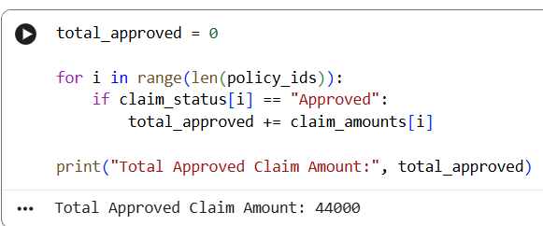
Task 2: Count Rejected Claims
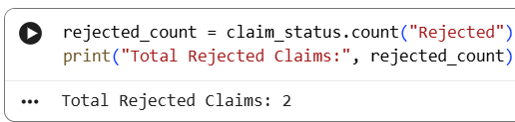
Task 3: High-Value Claims (> ₹10,000)
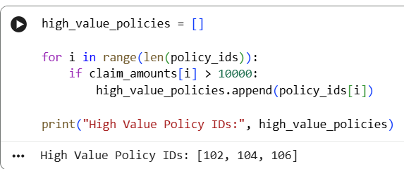
Task 4: Average Age of Approved Customers
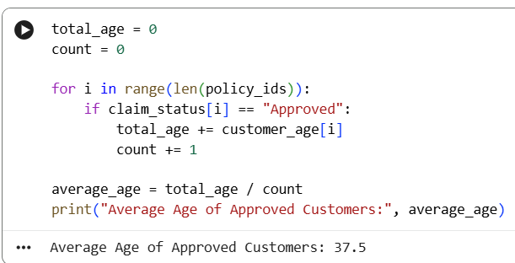
Task 5: Risk Category Tagging
